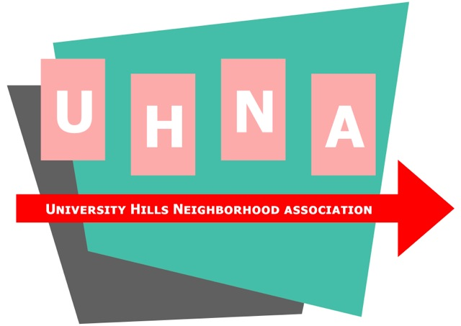

University Hills Neighborhood Association
P.O. Box 101392
Denver, CO 80250-1392
www.UHNA.com

To: Prospective Corporate Sponsors

Re: Annual Membership

Thank you for considering an annual sponsorship of the University Hills Neighborhood Association.

The UHNA is a 501(c)3 non-profit and is the officially recognized neighborhood association for University Hills in southeast Denver. We have been an active neighborhood association since the 1950’s, promoting social interaction of our residents and encouraging positive growth and development of local business and public services.

The last few years have seen a vibrant revival of interest in the UHNA. A new board has given new life to our group, and we have seen household memberships ($20 per year) jump from 20 to over 100 in just the past 18 months. We fully expect to realize our goal of 200 member households by the end of this year. Our many activities have been well attended, and we reasonably expect that over 500 residents will attend our annual picnic this August.

Becoming a corporate sponsor ($50 per year) is a great way not only to support the University Hills community, but a great way to affirm your business presence. Corporate sponsors are prominently displayed on our website, with hyperlink to their websites. They are also granted prominent positions at UHNA functions, from a market table at our picnic, to advertised sponsorship on event promotions, to “dinner nights” or “event nights” at businesses, as appropriate.

We look forward to having you as a valued corporate sponsor. We would appreciate the opportunity to tell you about our neighborhood and our events, and creatively work together to promote your business.

Thank you.

Andy Farr
UHNA President

